**Cloth Simulation With Effects**

Sahil Pethe **([ssp5329@rit.edu](mailto:ssp5329@rit.edu))**

Akshay Kalbhor **([abk7766@rit.edu](mailto:abk7766@rit.edu))**

What we set out to do:

First, we were thinking of creating a neural network learning based car simulation where it would do active collision avoidance using sensors, and after crashing, it would change its weights thereby preventing further collisions in Unity. But we later decided to scrap this idea as both of were unsure on how to use neural networks for the feedback. So, we decided to come up with a new topic: Cloth Simulation.

Design of our solution:

After researching for a while, we found out that most of the cloth simulations basically use a spring-mass model where there are a bunch of particles attached to different springs which in turn are attached to other particles in a mesh. The force exerted on a certain particle will transfer to the neighboring particles in a sort of ripple effect. This ripple effect is seen in real life cloth too.

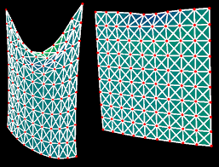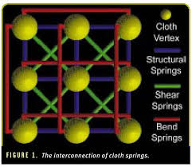

Implementation Details:

After some research, we found out about toxiclibs (Download: <https://bitbucket.org/postspectacular/toxiclibs/downloads/> Documentation: <http://toxiclibs.org/javadocs/>) which are a set of libraries which handle basic particle physics in Processing (<https://processing.org/>). The particle physics simulation is based on Verlet Physics which are used in games and real time rendering applications because it’s very less computationally intensive and less resource heavy. So, after coming up with a somewhat acceptable working demo, we presented the following as our midterm presentation demo: <https://youtu.be/Ivn1xl7mi3g>.

After showing the midterm demo, we thought that implementing this in Unity would be a better idea. But after thinking for a while, it dawned upon us that searching for a physics engine from scratch and then rebuilding the cloth using that physics engine didn’t make much sense. So what we ended up doing was creating new effects along with cloth simulation.

Results:

These are the following effects that we came up with:

1. **Collisions with physical objects (in this case sphere):**
   1. Dropping the cloth on a sphere: <https://youtu.be/bF6wt0CJoZI>
   2. Moving Sphere using mouse cursor and colliding with Cloth: <https://youtu.be/b8nBmAi7FT0>
2. **Wind Simulation by Colliding small randomly generated invisible spheres designed to remove themselves after a constraint:** <https://youtu.be/E1EnJGUAWfM>
3. **Cutting the cloth in half after the user presses a button on the keyboard:** <https://youtu.be/JKDFP4Tng6o>

.

Future Work:

* Implementing a more efficient and realistic looking cloth simulation
* Creating more effects on cloth
* Creating toolkit and libraries for tweaking settings and properties of cloth in UI